The Chi-Square Distribution: Review Problems

Questions 1 – 2 refer to the following real study:
A recent survey of U.S. teenage pregnancy was answered by 720 girls, age 12 - 19. 6% of the girls surveyed said they have been pregnant. (Parade Magazine) We are interested in the true proportion of U.S. girls, age 12 - 19, who have been pregnant.

Exercise 1
Find the 95% confidence interval for the true proportion of U.S. girls, age 12 - 19, who have been pregnant.
Exercise 2
The report also stated that the results of the survey are accurate to within ± 3.7% at the 95% confidence level. Suppose that a new study is to be done. It is desired to be accurate to within 2% of the 95% confidence level. What will happen to the minimum number that should be surveyed?
Exercise 3
Given: X ~ Exp(1/3) . Sketch the graph that depicts: P(X > 1).

Questions 4 – 7 refer to the following:
Suppose that the time that owners keep their cars (purchased new) is normally distributed with a mean of 7 years and a standard deviation of 2 years. We are interested in how long an individual keeps his car (purchased new). Our population is people who buy their cars new.

Exercise 4
60% of individuals keep their cars at most how many years?
Exercise 5
Suppose that we randomly survey one person. Find the probability that person keeps his/her car less than 2.5 years.
Exercise 6
If we are to pick individuals 10 at a time, find the distribution for the average car length ownership.
Exercise 7
If we are to pick 10 individuals, find the probability that the sum of their ownership time is more than 55 years.
Exercise 8
For which distribution is the median not equal to the mean?
- Uniform
- Exponential
- Normal
- Student-t
Exercise 9
Compare the standard normal distribution to the student-t distribution, centered at 0. Explain which of the following are true and which are false.
- As the number surveyed increases, the area to the left of -1 for the student-t distribution approaches the area for the standard normal distribution.
- As the number surveyed increases, the area to the left of -1 for the standard normal distribution approaches the area for the student-t distribution.
- As the degrees of freedom decrease, the graph of the student-t distribution looks more like the graph of the standard normal distribution.
- If the number surveyed is less than 30, the normal distribution should never be used.

Questions 10 – 14 refer to the following:
We are interested in the checking account balance of a twenty-year-old college student. We randomly survey 16 twenty-year-old college students. We obtain a sample mean of $640 and a sample standard deviation of $150. Let X = checking account balance of an individual twenty year old college student.

Exercise 10
Explain why we cannot determine the distribution of X.
Exercise 11
If you were to create a confidence interval or perform a hypothesis test for the population average checking account balance of 20-year old college students, what distribution would you use?
Exercise 12
Find the 95% confidence interval for the true average checking account balance of a twenty-year-old college student.
Exercise 13
What type of data is the balance of the checking account considered to be?
Exercise 14
What type of data is the number of 20 year olds considered to be?
Exercise 15
On average, a busy emergency room gets a patient with a shotgun wound about once per week. We are interested in the number of patients with a shotgun wound the emergency room gets per 28 days.
- Define the random variable X.
- State the distribution for X.
- Find the probability that the emergency room gets no patients with shotgun wounds in the next 28 days.

Questions 16 - 17 refer to the following:
The probability that a certain slot machine will pay back money when a quarter is inserted is 0.30 . Assume that each play of the slot machine is independent from each other. A person puts in 15 quarters for 15 plays.

Exercise 16
Is the expected number of plays of the slot machine that will pay back money greater than, less than or the same as the median? Explain your answer.
Exercise 17
Is it likely that exactly 8 of the 15 plays would pay back money? Justify your answer numerically.
Exercise 18
A game is played with the following rules:
- it costs $10 to enter
- a fair coin is tossed 4 times
- if you do not get 4 heads or 4 tails, you lose your $10
- if you get 4 heads or 4 tails, you get back your $10, plus $30 more
Over the long run of playing this game, what are your expected earnings?
Exercise 19
The average grade on a math exam in Rachel’s class was 74, with a standard deviation of 5. Rachel earned an 80.
The average grade on a math exam in Becca’s class was 47, with a standard deviation of 2. Becca earned a 51.
The average grade on a math exam in Matt’s class was 70, with a standard deviation of 8. Matt earned an 83.
Find whose score was the best, compared to his or her own class. Justify your answer numerically.

Questions 20 – 21 refer to the following:
70 compulsive gamblers were asked the number of days they go to casinos per week. The results are given in the following graph:
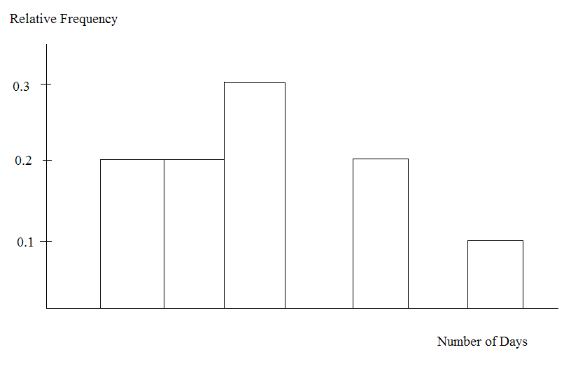

Exercise 20
Find the number of responses that were “5.”
Exercise 21
Find the mean, standard deviation, all four quartiles and IQR.
Exercise 22
Based upon research at De Anza College, it is believed that about 19% of the student population speaks a language other than English at home.
Suppose that a study was done this year to see if that percent has decreased. Ninety-eight students were randomly surveyed with the following results. Fourteen said that they speak a language other than English at home.
- State an appropriate null hypothesis.
- State an appropriate alternate hypothesis.
- Define the Random Variable, P’.
- Calculate the test statistic.
- Calculate the p-value.
- At the 5% level of decision, what is your decision about the null hypothesis?
- What is the Type I error?
- What is the Type II error?
Exercise 23
Assume that you are an emergency paramedic called in to rescue victims of an accident. You need to help a patient who is bleeding profusely. The patient is also considered to be a high risk for contracting AIDS. Assume that the null hypothesis is that the patient does NOT have the HIV virus. What is a Type I error?
Exercise 24
It is often said that Californians are more casual than the rest of Americans. Suppose that a survey was done to see if the proportion of Californian professionals that wear jeans to work is greater than the proportion of non-Californian professionals. Fifty of each were surveyed with the following results. 10 Californians wear jeans to work and 4 non-Californians wear jeans to work.
- C = Californian professional
- NC = non-Californian professional
- State appropriate null and alternate hypotheses.
- Define the Random Variable.
- Calculate the test statistic and p-value.
- At the 5% level of decision, do you accept or reject the null hypothesis?
- What is the Type I error?
- What is the Type II error?

Questions 25-26 refer to the following:
A group of Statistics students have developed a technique that they feel will lower their anxiety level on statistics exams. They measured their anxiety level at the start of the quarter and again at the end of the quarter. Recorded is the paired data in that order: (1000, 900); (1200, 1050); (600, 700); (1300, 1100); (1000, 900); (900, 900).

Exercise 25
This is a test of
- large samples, independent means
- small samples, independent means
- dependent means
Exercise 26
State the distribution to use for the test.

